Step 1.
Go to BLM Online Corral to complete BLM Adoption Application: https://wildhorsesonline.blm.gov/Account/Login
Login and complete a new application OR select “register as a new user” if you have never done an online application before.
-Select “adopting” and complete sections 2&3
-Under “animal group/organization name” put 2023 Sacramento TIP Challenge and Amber Espinoza as “point of contact”.
*Youth trainers must have an adult as the applicant and signatures on the BLM application.
Once your Online Corral Application is approved you must submit a screenshot of the approval with your TIP Challenge application or it will not be accepted. It takes BLM 1-3 business days to give approval so complete ASAP.
  - Step 2.
  - Complete TIP Challenge Competitor Application
- Application Instructions
- The forms are editable PDFs and compatible with browsers like Chrome and Microsoft Edge. They also work with phone apps such as Adobe Fill and Sign. If you print the forms to complete, please scan and create a PDF to email (please do not send jpg files – _except for headshot). There are many apps – _Scannable, Fast Scanner, etc. for the phone that will do this. You can use the “Notes” app on your Iphone to do this as well. Also, please write legible and ensure file images are clear and readable.

  - a. Include a headshot photo.

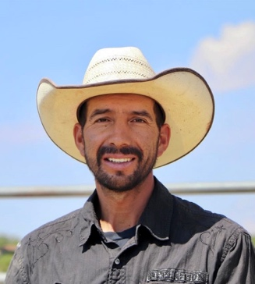
Example of a good headshot.

  - b. Include a personal bio (3-5 sentences). Please type this into the email and not a photo of a handwritten or typed note.

Step 3.
Email all forms (TIP Challenge application, headshot, bio & screenshot of BLM approval) to sactipchallenge@gmail.com on or after 12:01AM, Sunday January 15, 2023 (applications sent in early will go to the end of the list for that day).

IMPORTANT DATES & Information:

January 8, 2023 – Applications sent to those who signed up with the interest form.

January 10, 2023 – Applications posted online for everyone to access.

January 15, 2023 – Applications may be submitted starting at 12:01AM. Horse selections will be based on order applications received. Youth have priority over yearlings as long as completed application has been submitted.

January 25, 2023 – First round of trainer approval letters will be e-mailed.

January 25&26, 2023 – Pictures/video of animals will be taken.

January 28, 2023 – Pictures and video of available animals will be uploaded to Facebook group. Join group here: https://www.facebook.com/groups/westtipchallenge/

January 30, 2023 – Animal selections will take place. Trainers will receive a google form to submit their selections and preferred pick up location via e-mail (make sure your e-mail address on the application is correct!)

January 31, 2023 – Finalize picks and pick up location.

February 3, 2023 – FINAL date we will accept new applications and animal selections.

February 17&18, 2023 – Animal pick up at Litchfield and Ridgecrest Corrals in CA. ALL adoption paperwork and payment will be completed with BLM prior to pick up.

June 9-11, 2023 – Competition dates at Murieta Equestrian Center in Rancho Murieta, CA.

